# *Aryan Sai Venkat M 230701040 CSE A*

# Exp No:12

# File Organization Technique Single and two level directory

## PROGRAM

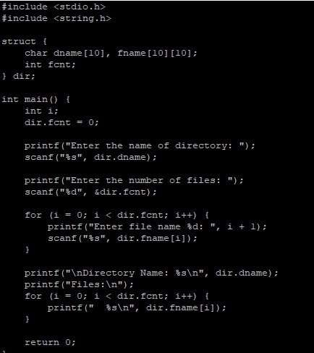

## OUTPUT

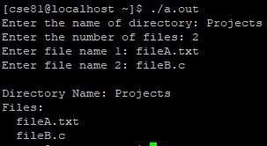

## PROGRAM

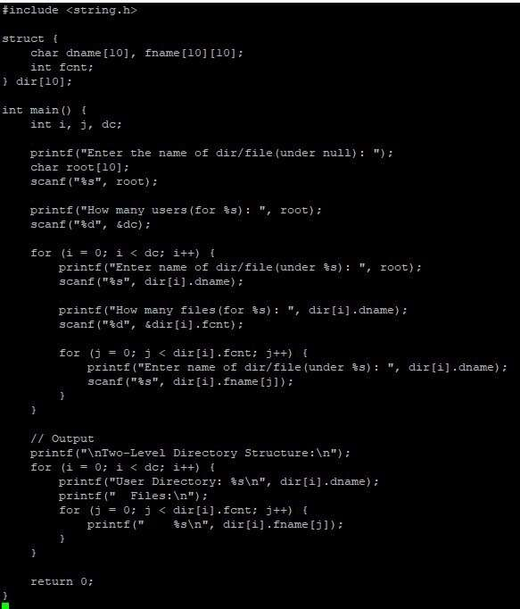

## OUTPUT

